Intelligent Semi-automated Serious Educational Game Generation for the SimSYS Serious Educational Game Development Platform

TR xxxxx

author list

Acknowledgements

xxx.

Abstract

yyy.

Table of Contents

Acknowledgements ii
Abstract iii
Table of Contents iv
1. Introduction 1
2. Related Work 2
2.1 Introduction 2
2.2 Code Generation 2
2.2.1 subheading 2
2.2.2 subheading 2
2.3 Automation in e-learning, games, serious educational games 2
2.3.1 subheading 2
2.3.2 subheading 2
2.4 Conclusions 2
3. Your solution 3
3.1 Introduction 3
3.2 Detailed description 3
3.2.1 subheading 3
3.2.2 subheading 3
3.3 Tool Support 3
3.3.1 subheading 3
3.4 Validation results 3
3.4.1 subheading 3
3.4.2 subheading 3
3.5 Conclusions 3
4. Conclusions and Future Work 4
4.1 subheading 4
4.1.1 subheading 4
4.1.2 subheading 4
4.2 subheading 4
4.2.1 subheading 4
4.2.2 subheading 4
5. References 5
Appendix A. title here 6

Introduction

// a place to start is one paragraph for each of these:

Intro. to changing educational needs, how e-learning fits into that shift (include definition with reference for e-learning)
Intro. to serious educational games (include definition with reference of serious educational game)
Intro. to automation in serious education games (what other researchers have automated)
Intro. to the SimSYS Game Development Platform (overview, with references)
Focus in on the intelligent semi-automated game generation component
Why is this research needed?
Brief overview of the component, research methodology (including validation), and results
Structure of this report

Related Work chapter – about 15-20 pages, including figures

Define comparison criteria, with reference for each definition
- How will the different approaches be cross-compared?
- - goal of the approach, application to education domain, theoretical foundation of the approach, fully vs. semi-automated, notation, validation approach (empirical or theoretical), notation, tool support, …

Define a collection of comparison criterion that are subsequently applied to each technique below; one criterions gets one subheader /paragraph.

Each criterion needs to have a clear, concise, correct, complete definition (text or mathematical); include references to define where you got each definition from.

Game-based learning has some of the most desirable learning approaches embedded such as active learning, experiential learning, situated learning and problem-based learning. There are a growing number of domain experts keen in adopting this learning approach and the numbers will continue to grow with more realizing the potential that computer games hold. Learners themselves are ready for such approaches as they are increasingly familiar with gaming culture and the technology to support game-based learning is more affordable and widely available. The only puzzle to realize the vision of game-based learning is the availability of high-level tools made specifically for non-technical domain experts to assist them in creating educational games in an affordable and timely manner.
MDE offers the basis for development of high-level tools. Architecting a model-driven educational games development environment will require an educational game Modeling language, a framework that can integrate media and game functionalities. Transformation engines and code generators. In this section, we survey the literature in the domain of game design, game software engineering and MDE, and summarize the key developments that are propelling games development towards the model driven approach [1].
Traditionally, accessibility in games has been addressed individually in most of the cases, either adapting a specific title to meet the needs of a particular user profile , or developing games for a specific community of users with disabilities . Audio games, for example, are designed for users with a visual disability. How-ever, other approaches have adopted a more general and holistic perspective, proposing frameworks and methodologies that consider the needs of different profiles of users that could also be applied to different types of games.
For example, in the authors propose Unified User Interface Design, a methodology for designing universally accessible games where game tasks are devised with-out considering a specific modality or interaction device. In further design phases, alternative interaction methods are designed for each task depending on the needs of the target audience. Therefore the game design is extensible, facilitating the subsequent inclusion of accessibility features to cater for the needs of other users. [3]

The e-Adventure Educational Game Platform
e-Adventure is a game authoring platform especially oriented to education. Although e-Adventure’s capabilities support the creation of a variety of 2D games, it was originally focused on point-and-click adventure games. This decision was driven by the consideration that these are the most appropriate genres for education because of their strong narrative underpinnings and pre-dominance of reflection over action. From an accessibility perspective, this genre does not pose barriers such as time pressure or fast-paced action, although a variety of barriers related to modality remains (they are highly visual, require moving a mouse for identifying objects, etc.).
There are two components in e-Adventure: a game editor used to create the games and a game engine, used to run them. The typical workflow is to create and test the games with the editor, and then use editor's exportation features to produce a distributable package bundling all the assets that the game engine needs to process the games, which are a set of XML documents that describe the game and art resources (images, sounds, videos, etc.). The game editor includes education-oriented features and tries to simplify the game creation process as much as possible.
The game universe in e-Adventure games is defined by composing elements of different types: characters, items, active areas, and the game scenarios (a.k.a. scenes), which are composed by a 2D background image and a set of interactive elements. [3]

Introduction
// introduction to what is covered in this section
Survey could cover:
Automation in non e-learning, serious educational games:
- Code generation research (there is a lot of this we can draw on)
  - OMG MDA model transformations
  - Template based, graph based, other? Non “intelligent” vs. intelligent?
Automation in e-learning, games, serious educational games*
- Recommender systems research
- Ontology research
- other

*closest – find these if possible (:
Game-based learning harnesses the advantages of computer games technology to create a fun, motivating and interactive virtual learning environment that promotes problem-based experiential learning. Such an approach is advocated by many commentators to provide an enhanced learning experience than those based on traditional didactic methods. However, the adoption of such a seductive learning method engenders a range of technical, educational and pedagogical challenges, including: (i) how to enable domain experts - with little computer games development skills - to plan, develop and update their teaching material without going through endless and laborious iterative cycles of software and content development and/or adaptation; (ii) how to choose the right mix of entertainment and game playing to deliver the required educational and pedagogical lesson/teaching material; and (iii) how to reuse existing games software frameworks and associated editing environments for game-based learning. Much research is already underway at addressing the stated challenges: however, these approaches do not address the key challenge of facilitating the planning and development of teaching material with the right mix of pedagogical elements, educational components and fun. Thus, this study aims to investigate the use of model-driven software engineering approaches to facilitate non-technical domain experts (teachers) to plan, develop and maintain game-based learning resources regardless of the intricacies of the game engine/environment (platform) used.
This article investigates the state-of-the-art in model-driven game development to provide a summary of developments in game design languages, game software Modeling languages. Game models, game software models, model-driven game frameworks, game software frameworks, model-driven engineering tools and assistive user interfaces. The findings from this survey will prove a useful guide for future development of high-level educational game creation tools for game-based learning.

Code Generation // collection 1
xxx

Technique 1
Overview paragraph
What papers are discussed here? [ref][ref][ref]

Comparison criterion

Model-Driven Serious Games Development Framework
MDE refers to a software development approach which focuses on creation of models that represents the system under-study (SUS) and subsequent generation of fully working software artifacts’ from these models. This is made possible using a Domain-Specific Modeling Language (DSML) for describing the SUS as a model, and transformation engines and generators that bridge technology barriers in providing software solutions.
As part of this research, the requirements for our model-driven framework are formulated based on our analysis on studies of game-based learning, serious games design, games development and MDE to provide a comprehensive and collective view . These requirements are listed as follows;
- to embed best practice for designing serious games for educational and training purposes focused on five aspects of serious games design namely game-play, game structures, game content, motivation and serious game design workflow ;
- to provide support for a myriad of game software frameworks irrespective of the underlying model and support transparency in movement between frameworks where appropriate;
- to loosely couple artifact generation within the framework so as to provide maximum flexibility for game developers to develop code generators for different game software frameworks that comply with the framework;
- to enable integration of externally produced art assets and game functionality within the framework; and
- to encapsulate technical aspects of game design and guide users in completing serious games design requirements formally via assistive user interfaces.

The listed requirements provide crucial pointers for architecting the ideal model-driven framework for supporting development of serious games. Only a few of these characteristics are exemplified in the SharpLudus Game Software Factory, MDGD framework and Board Game Model. The basis of a model-driven approach is to logically map the requirements to corresponding and technically elaborated semantics for composition into artifacts. [1]

The simplicity of this architecture tightly couples the game software model to the game software framework thereby limiting the type of serious game that can be produced. Our new model-driven serious game framework is featured in Figure 1 and consists of nine modules namely: (1) User Interface (UI), (2) Models, (3) MDE Tools, (4) Components Library, (5) Code Templates, (6) Artefacts, (7)Technology Platform, (8)Operating Platform and (9) Software. This configuration loosely couples the modules allowing the framework developer to flexibly substitute modules while maintaining the integrity of relationships among the modules via well-defined interfaces. It also clearly divides the views of entities while promoting structured and systematic workflow.

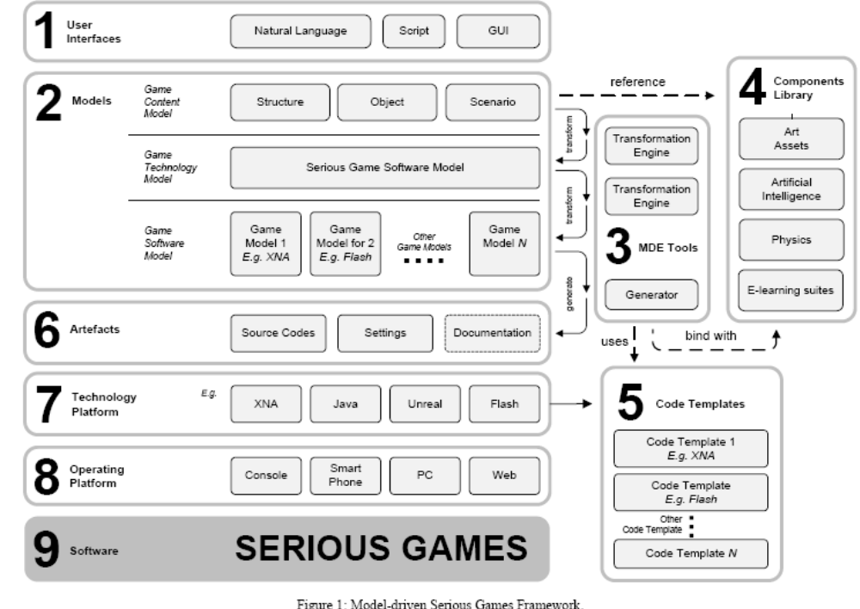

The benefits of model-driven serious games development are certainly attractive to many, but realization of such a development approach is still challenging for developers. These challenges include definition of modeling languages that can explicitly represent the problem domain, integration of models from multiple and overlapping views that may
result in conflict, maintaining the consistency of models once transformed, testing of the transformation process and integration of generated code with foreign code. These challenges must be addressed before any model-driven serious games development environment can be developed to facilitate non-technical domain experts in development of serious games for game-based learning.[x]

Comparison criterion 2

GAME SOFTWARE MODELING LANGUAGES
Modeling is a formal process of documenting a design using syntactically composed reserved words or graphical notations. The term Modeling refers to documenting aspects of game design. Through Modeling, a conventional software engineer captures the necessary requirements to produce a concrete model that best represents the software specifications of the game software. In addition, Modeling allows the engineer to study problems and look for flaws in the design prior to development of the software system. Flowcharts, Data Flow Diagrams (DFD), Statechans, Z-Notation, Petri-nets, Business Pmcess Modeling Notation (BPMN), Integrated Computer-Aided Manufacturing Definition Language (IDEF) and UML are some examples of software Modeling languages that engineers can use to express the design of the game software.
Modeling was historically mathematically demanding and modeling languages were developed to suit programming languages during the era such as FORTRAN, ALGOL, LISP and COBOL. As later generation programming languages such as C, Pascal and Ada which were designed to structure programs logically began to surface, software Modeling took on a function-oriented paradigm. At present, Object-Oriented ( 0 0 ) modeling is a de facto approach in the software industry as it promotes abstraction, encapsulation and reusability of software code. Although most software Modeling languages mentioned can be used to model aspects of game software, only a few are actually used in practice.
Tokenizariort represents each game object (both intractable and non-intractable) as tokens. Interactions between tokens are game developers to think in tokens and the associated interaction, but lacks many aspects necessary to represent the game software in its entirety. Simple casual games can be modeled using this approach without much complication. However, for modern computer games that offer more elaborate interactions and a greater number of tokens, this approach is not suitable as complexity of Modeling increases exponentially. Another major setback for tokenization is evident during translation of model to software code. Although examples are available, it is not a straight forward process as there is much information such as the game object's behaviour, setup of scenarios, flow of events and progressions still missing in the software model.

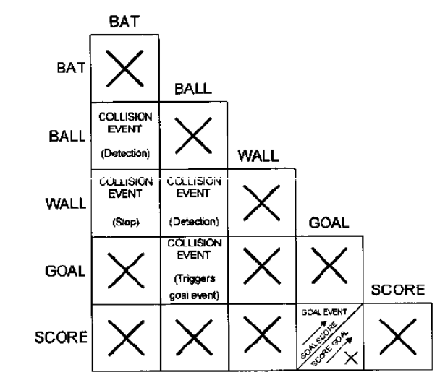

Figure 2. Tokenization Interaction Diagram of Pac Man Game (Rollings & Morris, 2004).

As many aspects of games deal with a collection of states that change based on interaction and rules, Statecharts or Finite Srare Machine (FSM) diagrams are ideal candidates for Modeling games. The FSM has been mostly used in Modeling game A1, although other game aspects such as character behaviour, game flow and game scenario can also be modeled with this approach. Rollings & Morris's approach is a pictorial version of FSM with slight modifications in notation for Modeling a game object's behaviour (see Figure 2). A square is used to represent an individual state of a game object, while a circle denotes an event. Lines with a coloured dot at the end show the transition between states and the incoming event that triggers a transition. Coloured dots are used to pair the event to the transition between states in cases where there are more than one event referring to the same state. A circular arrow is introduced in the FSM diagram to include events that can cause entry to a state. Kienzle, Denault & Vangheluwe's approach uses a variant of Rhapsody Statecharts which combines statecharts and class diagrams to represent properties and behavior of game objects (see Figure 3). In addition to class diagrams, statecharts are accompanied to switch or alter the state of a game object when certain conditions are met. Rounded rectangles represent the state while transition of state is shown using an arrow with conditions. Statecharts can be nested to create a multi-level statechart, but every statechart can only have a single begin state which is denoted by a filled black circle. Rhapsody Statecharts are a better approach than the pictorial FSM or classical statecharts as they represent both properties and methods of a software component and can easily used for representing other aspects of game software.
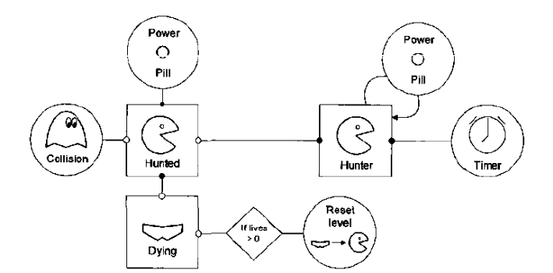
Figure 3: Statechart diagram for pacman game

Comparison criterion 3

GAME SOFTWARE FRAMEWORKS

A game software framework (also known in the game industry as a game engine) is a set of Application Programming Interfaces (APls). It consists of software components that perform graphic rendering (2D or 3D), game physics computation such as collision detection, collision reaction and locomotion, programmed intelligence, user input, game data management and other supporting technologies to operate the game software. These software components are built to manage, accept, compute and communicate data with other software components without fail. An appropriate API can increase the productivity of game developers allowing them to reuse proven and tested software code to produce a variety of computer games within the scope of the software framework. Game software frameworks vary depending on technology features that are often constrained by particular game genres, technology platforms (hardware) and visual dimension of the game world (2D or 3D), hut technology components such as graphics, sound, user input, basic game physics and user interfaces remain essential across all game software frameworks. For instance, the Unreal engineJ is suitable for development of action or adventure games in first or 3m person view but it will require modification to include necessary physics code if it to be used to support sports game genres. Not all game software frameworks support all features since integrating these technological components under a single framework is a highly complex and expensive task. Furthermore, not all computer games software will require the entire collection of software components to operate. Budget, support, features offered, ease of use, suitability, royalties and targeted hardware platform are some examples of key criteria
which can help to decide the most suitable game software framework for a project. Identifying features supported and techniques used in game software frameworks can help to provide valuable information for MDE developers to architect a framework that is robust and interoperable.
There are many game software frameworks developed to date (at the time of writing, there are 297 3D game engines registered at the DevMaster. net' website). In general, these game software frameworks can be categorized from a purely financial point of view as being one of commercial, open source and proprietary, or using the visual dimension they can cater for i.e. 2D or 3D

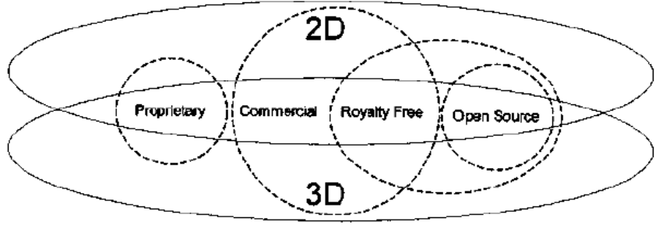
figure4

Commercial game software frameworks are much more stable and offer a reliable (supported) option over open source game software frameworks. The Brque Game Enrine (TGE) is an example of royalty-free game engine which is offered to developers at a very affordable price compared to other commercial game software frameworks, in which TGE developers only pay for the technology once and are allowed to develop as many games software applications as they wish. Unreal engine, Source engine, CryEngine and id Tech (formerly known as Quake Engine) are some notable examples of highly sophisticated game technologies that can help developers to produce high-quality games. These premium game technologies are available for licensing and require a one-off royalty payment (per-title fee) or royalty for every copy of game sold, or both. However, some of these are made available for free for educational purposes such as the 3DSTATE 3 0 Engine, XNA, CryEngine 3, Unreal Development Kit (UDK) and Unity 3 0 .

Comparison criterion 4

MODEL-DRIVEN ENGINEERING TECHNOLOGIES
Integrated environments can provide a complete solution where the practitioner can define a DSL and its transformation rules to generate the desired software artifacts and host the Modeling component within the same environment, while a code framework provides the basis for development of MDE tools to support the MDD.

INTEGRATED ENVIRONMENTS
MetaCase MetaEdit+'9 is a commercial integrated environment for MDE. It provides a collection of tools to design a DSML by defining the concepts, constraints associated to the concepts, symbols representing the concepts and a generator to produce the desired software artifacts with MetaEdit+Workbench. Modeling using the defined DSML is hosted within the Meta Edit+ environment. The MetaEdit+ Model extends the generic Modeling environment to provide a range of different views ill! owing !hp development team to view and edit or manipulate the model as a diagram, matrix or table. In addition, it provides the necessary tools for management of the model and its contents and provides support for a multi-user environment. Microsoft DSL Tools is another integrated environment for MDE made available as an extension to the Microsoft Ksual Studio IDE (Cook, et al., 2007). It provides the necessary tools for defining a DSML, modeler and generator to generate textual artifacts from the model within the Visual Studio environment. In DSL Tools, a domain model is created using a UML like Modeling language and a DSML is then represented with graphical notations consisting of shapes and connectors. Relevant generators can be defined in Extensible Style Sheer Language Transformation (XSLT) and text artifacts are generated through the Microsoft XSLT engine or by through a parameterized text template generation approach. Visual Paradigm's S m n Development Environment(~S~D E) is another commercially developed plug-in to support MDE practices which offers capabilities to model in UML, entity relationship diagram, data flow diagram and others, generate code for 15 different programming languages, team collaboration capabilities, roundup engineering and can be integrated with well-known IDES such as Visual Studio, NetBeans, Eclipses and intelligent IDEA. The Modeling environment is hosted within the supported IDE and code is instantly generated in the code editor view allowing both forward and reverse engineering.
Apart from commercially driven integrated environments for MDE, there are also non-commercial products available. GME, developed at the Institute for Software Integrated Systems (ISIS) at Vanderbilt University, provides a similar facility for defining a DSML and hosting Modeling within the same environment . In GME, a domain model is modeled in UML and assigned with graphical representation while modeling rules are defined using Object Constraint Language (OCL). Models are then saved directly in XML format or translated using an external interpreter (generator) into other textual artifacts using Microsoft Common Object Model (COM) technology through extensions to the GME.
GEMS" is a meta-Modeling tool developed by ISIS at Vanderbilt University that provides GME-like meta-Modeling to create Modeling tools that can be hosted within the Eclipse environment. It uses Eclipse modeling technologies such as EMF and Graphical Modeling Framework (GMF). Like GME, a DSML is created in GMES using UML-like notations and later ported automatically to Eclipse as plug-in. Generators and transformation engines can be created for the Modeling environment created using Open Architecture Ware2' (OAW), Java Emitter Templates2* (JET), and Atlas Transformation Languagez4 (ATL) to transform the model into desired textual artifacts.
The NetBeans IDC5 also provides similar facilities for modeling using a UML plug-in26 and code generation using a template engine such as FreeMarkeF. The UML plug-in enables the Modeling environment to model the SUS using a range of supported UML diagrams such as activity diagram, class diagram, sequence diagram, state diagram, and use case diagram as a Java platform model or PIM. The FreeMarker code templates associated with the diagrams can then be customized to generate the desired Java source code.
Among the reviewed integrated environments for MDE, MetaCase MetaEdit+offers comprehensive and customizable Modeling features, which can be integrated into many IDES, and it offers a facility to create generators for any text artifacts. GME is also a standalone tool with a similar aim, but suffers from the lack of a built in generator. For Visual Studio users, Microsoft DSL Tools is an alternative to MetaEditi, where a DSML can be created, hosted and generate code entirely within the Visual Studio environment.
Similarly, GEMS provides a facility to create the Modeling environment as an add-on to the Eclipse IDE with support to create generators for any text artefacts. Each of the reviewed integrated environments provides the facility to support the MDE process in one way or the other. The SDE allows users to model using UML diagrams, entity relationships diagram, BPMN, process map and others. It also provides great support for code generation and integration with well known IDES.
The NerBeans IDE with the UML plug-in is an open source alternative to SDE. Selection of the integrated environment will ultimately depend on the available budget to invest and choice of development tools.

CODE FRAMEWORKS
Code frameworks for MDE can generally be divided into two categories; diagramming and transformation. IBM's /LOG Visualization the Eclipse Graph Editing FrameworPY (GEF) are examples of diagramming code frameworks that provide the software components such as 2D graphics, notation palette. environment layout support viewer, connection anchoring, connection muting, connection decoration and cursor support which are necessary for creation of a diagramming environment. ILOG Visualization is licensable as GUI components for the .NET, Java, C++ and Adobe Flex platforms, whereas GEF is only available as a plug-in on the Java platform specifically for the Eclipse IDE.
The Eclipse Modeling Framework (EMF), CodeWorkerio and ATL are examples of transformation code frameworks. The EMF provides the facility to build a code generator in the Eclipse IDE. It accepts a model expressed in annotated Java, XML or XML Metadata Interchange (XMI) and transforms it into Java implementation classes or a formatted XML document. An alternative to EMF is CodeWorker which is freely available as a Java interface, .NET assembly and an Eclipse plug-in. For model-to-model transformation, the ATL can he used to transform a set of source models to a set of target models. The ATL is offered as plug-in to the Eclipse IDE. The Eclipse Graphical Modeling Framework" (GMF) provides a full featured Modeling environment by integrating the diagramming features from GEF and the transformation features from EMF. This reduces the complication for developers who want to create a full-featured Modeling environment in the Eclipse IDE. For non-Eclipse users, Modeling environments can be built on the integration of ILOG Visualization and CodeWorker. Building MDE tools based on these code frameworks described can be time consuming compared to the use of an integrated environment . However, it provides great flexibility for developers to create custom interfaces and target code generation to required platforms more accurately.

Comparison criterion …

DEVELOPING A META-MODEL FOR A EDUCATIONAL SIMULATION GAME (MMESG)
A. Components of MMESG
Our proposed simulation-game meta-model keeps in mind a holistic approach to gaming and learning. It establishes that, in addition to being engaging and entertaining, educational simulation games are immersive learning environments that embed specific learning objectives into a set of challenges expressing particular skills as classified by a learning taxonomy.
To facilitate the pedagogical base for rapid development of simulation games across curricula and training programs we have separated the game functionality (i.e. the raw simulation components) from the knowledge content and student assessment via specific modalities of game challenges (Figure 1). This allows faculty and trainer designers to input and switch out content quickly from course to course and, depending on student progress, from class to class. That is, instructor designers could toggle a laboratory or a crime scene environment for the simulation context, and then input chemistry- or forensic-specific content in the game challenges that can vary from course section to course section.

1) Knowledge Base
Every discipline or program has an information or knowledge set of which students must demonstrate some level of competency by the end of their education. In software engineering, international standards determine competency. The SE2004 guide organizes the Software Engineering Education Knowledge (SEEK) into three levels: knowledge areas; units; topics. SEEK defines ten knowledge areas, representing generally recognized subdisciplines of software engineering. It then parses smaller units of knowledge from the ten areas, about which students need various levels of knowledge and skills competency.

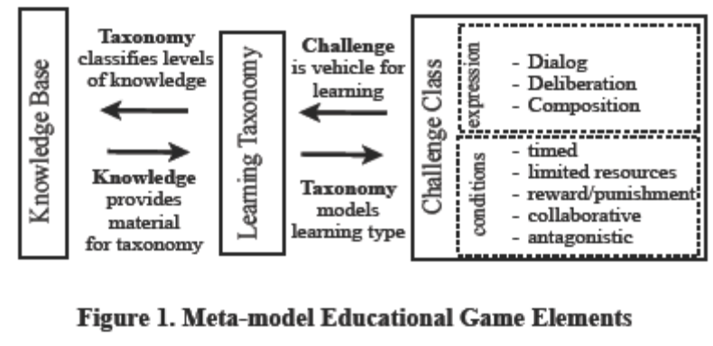

2) Learning Taxonomy
The Learning class (taxonomy) represents the skills and abilities reflected in the simulation game learning objectives. For our meta-model, we use Bloom’s taxonomy as the types of skills that student players must demonstrate a level of competency in the simulation game challenges. For each knowledge base topic, one or several of Bloom taxonomy levels is assigned, indicating what skill level graduates should possess: knowledge (remembering learned material), comprehension (understanding information and the meaning of course content), application (ability to use learned material in new and concrete situations), synthesis and analysis (seeing the connections and components of larger systems), and evaluation (being able to assess the value of varied and variable information within specific contexts and requirements).
Game challenges align with the Learning class taxonomy. Instructors can use different challenges to accentuate different levels of knowledge. When a faculty member would like to assess content retention, then he or she would toggle a Dialog challenge asking students to demonstrate knowing a term’s definition. Likewise, more complex challenges that require demonstrating higher skill sets within the simulation game, provide opportunities for increased knowledge and skills building.

Comparison criterion n

Technique 2
Overview paragraph
What papers are discussed here? [ref][ref][ref]

Comparison criterion 3

Comparison criterion 4

Comparison criterion …

Comparison criterion n

…

Technique n
Overview paragraph
What papers are discussed here? [ref][ref][ref]

Comparison criterion 1

Comparison criterion 2

Comparison criterion 3

Comparison criterion 4

Comparison criterion …

Comparison criterion n

Automation in e-learning, games, serious educational games // collection 2

Technique 1
Overview paragraph
What papers are discussed here? [ref][ref][ref]

Comparison criterion 1

Games and Schools
Although games can be effective learning environments, not all games are effective, nor are all games educational. Similarly, not all games are good for all learners or for all learning outcomes.
Games may remain on the sidelines until rubrics and evaluation strategies are developed that assess a game’s value. “Faculty members need training to analyze, design, develop, implement, and evaluate digital game-based learning (DGBL). Staff members need training to support faculty during this process.”
How games are used is important as well. Simply using games may not be very effective; use is not synonymous with integration. In fact, use of one strategy is often assumed to replace another (for example, a game replacing face-to-face instructional time). What is more important is to consider how to add games to the educational tool set, blending them with other activities. Integration requires an understanding of the medium and its alignment with the subject, the instructional strategy, the student’s learning style, and intended outcomes. Integration of games into curricula is much more likely to be successful than mere game use.
There are a range of options for integrating games into education. Strategies include allowing students to create their own games or integrating commercial games into the curriculum. If games are integrated into the curriculum, it will be important to understand what types of games promote the desired learning outcome.
For example:

• Card games promote memorization, concept matching, pattern recognition
• Jeopardy-style games encourage quick mobilization of facts, labels, concrete concepts
• Arcade-style games are good for improving speed of response, automaticity, and visual
processing
• Adventure games are useful for promoting hypothesis testing and problem solving.

If games are integrated into the curriculum, strategies may go beyond game play. An alternative to playing a game is to ask students to critique a game. This allows students to explore not just the subject but how the game is structured. Since most games were not designed for educational purposes, it is not surprising that details may be missing or facts incorrect. Another strategy is to have students discover what is missing or incorrect in a game.Beyond selection of a game, educators must consider when and how to integrate a game into the curriculum or the class. Options include use as a

• preinstructional strategy,
• coinstructional strategy (augmenting, illustrating, discussing), and
• postinstructional strategy (for assessment and synthesis).

Games may also be considered a part of the informal educational environment.

Comparison criterion 1
This study examines the development process of digital game-based learning environments (GBLE). The goal of this study is on constructing a prescriptive
process model for GBLE development.

GBLE Concept Creation
Building the prescriptive capability pattern for GBLE concept creation activity is a high priority task in this part of the study.
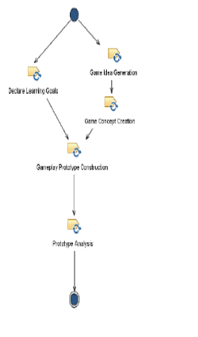
Figure 9.2: The activity diagram of GBLE concept creation capability pattern.

The requirements that these results give to the GBLE concept creation activity can be satisfied with the following capability pattern (Fig. 9.2): The activity begins with simultaneous learning goal definition task. At the same time game idea and after that the game concept are created. When these tasks are completed a game concept prototype is constructed based on the learning goal definition and the game concept document. After that the prototype is analyzed by playtesting. The prototype analysis is used when reviewing the result of the activity.
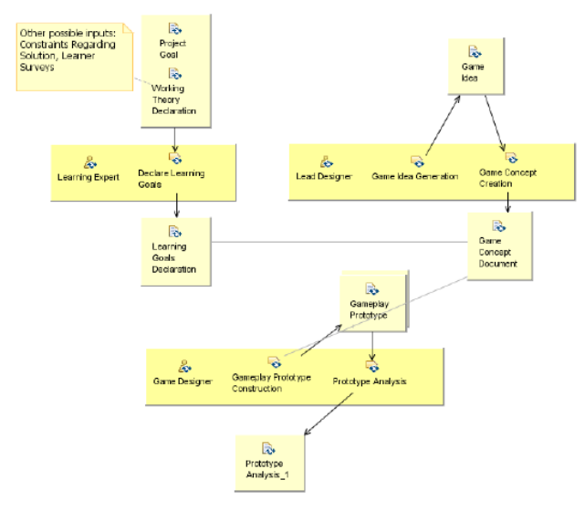
Figure 9.3: The activity detail diagram of GBLE concept creation capability pattern.

The capability pattern of this activity is further illustrated by the activity detail diagram. The learning expert is responsible for the learning goal definition task. The lead designer is responsible for game idea generation, game concept creation and prototype construction. The both aforementioned roles perform the prototype analysis. All of these tasks also have optional additional performers: HCD designer and user designer in case HCD methods are used in the concept creation and stakeholders in the prototype analysis task.
This capability pattern demonstrates the separate tasks in GBLE concept development adequately. It does not, however, demonstrate the idea that learning goal definition, game idea generation and game concept creation are interconnected tasks. Therefore an alternative capability pattern that demonstrates this has been developed.
In this capability pattern learning goal definition, game idea generation and game
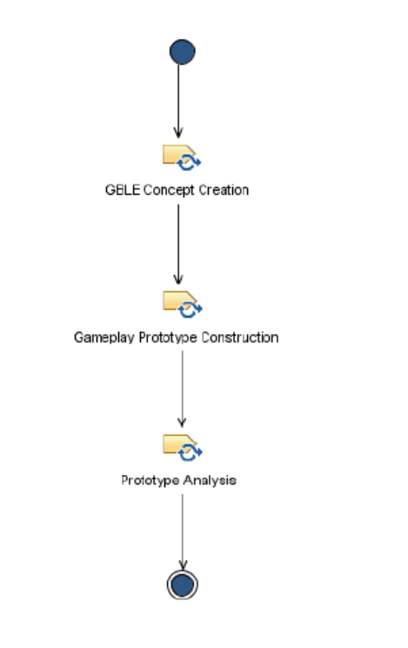
Figure 9.4: The activity diagram of the alternative GBLE concept creation capability pattern.

Concept creation are combined into a single task, GBLE concept creation. This produces a single work product, GBLE concept document. The GBLE concept document includes the game idea description, game concept document and learning goal definition. The primary performers of GBLE concept creation task are the learning expert and the lead designer. Otherwise this the make-up of this pattern is identical to the first capability pattern. These two patterns are alternatives to each other and the person responsible for planning the project process should choose between them based on whether emphasizing the distinct tasks or the importance of collaboration is more important in the concept creation of the project in question.

Comparison criterion 2
Experiences Developing Accessible Interfaces with e-Adventure
We have used e-Adventure to explore the automatic generation of accessible interfaces for two games that we present in this section as case studies. Upon the e-Adventure source code, we built components that adapted the user interface depending on a given user profile. In this section we will elaborate on the level of automation achieved in each case. For each case, we have evaluated the usability from the end user’s perspective, by asking different users to interact with each type of resulting accessible interface. Further technical details on the implementation of these interfaces can be found on previous publications .
The official e-Adventure distribution complies out-of-the-box with a certain level of accessibility for users with hearing disabilities, as all the information provided by audio can also be displayed with text. It is also accessible for users with a cognitive disability as it integrates an adaptation engine that allows game authors to tailor the game experience to each user capabilities (e.g. alternative contents or puzzles or skip-ping complex parts). For that reason, our work has focused more on improving accessibility for users with visual and motor disabilities.
Fully Automatic Adaptation of Interfaces - The case of 1492
In a previous work we have described a prototype built upon e-Adventure v1.0 that supported alternative modalities through a combination of input and output modules. Two user profiles were considered: blind users and users with a motor disability. Among the wide variety of levels of visual impairments, we characterized the blind user profile as users that needed the aid of screen reading software to use a computer. We considered users with a motor disability as those needed of using voice recognition software to interact with a computer due to reduced or lack of mobility. Both user profiles encounter barriers when interacting with point-and-click applications as they are not able to use the mouse.
The game author was only allowed to enable or disable the modules during the exportation process. All the adaptation to the user profile was performed automatically by analyzing the game description XML files and art resources (see Fig. 1).
The results were two new modalities which had common inner workings. The interaction was performed through short commands formulated in natural language (e.g. "grab the notebook" or "talk to the character"). An interpreter received the commands, executed them if they were correct, and provided feedback about the results using the appropriate channel for the active user profile (auditory for the blind user through a built-in text-to-speech engine, text for the user with a motor disability). Blind users introduced the commands using the keyboard, while users with a motor disability used speech.

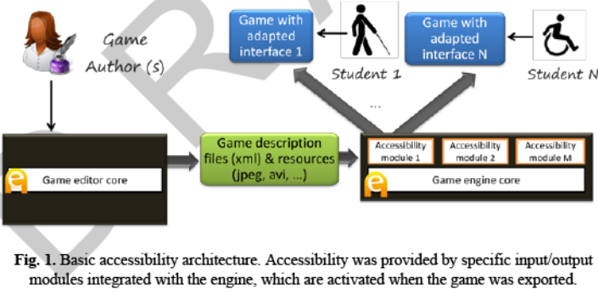

Command processing was directed by a regular grammar combined with a fixed list of synonyms for relevant verbs (actions) and nouns (interactive elements). The regular grammar was automatically generated from the description of the game, taking the actions defined for the interactive elements available in each game scenario. During game play, the number of actions and interactive elements available in as directed by a regular grammar combined with a fixed list of synonyms for relevant verbs (actions) and nouns (interactive elements). The regular grammar was automatically generated from the description of the game, taking the actions defined for the interactive elements available in each game scenario. During game play, the number of actions and interactive elements available in flexibility of the accessibility features that now could be configured with the game editor.

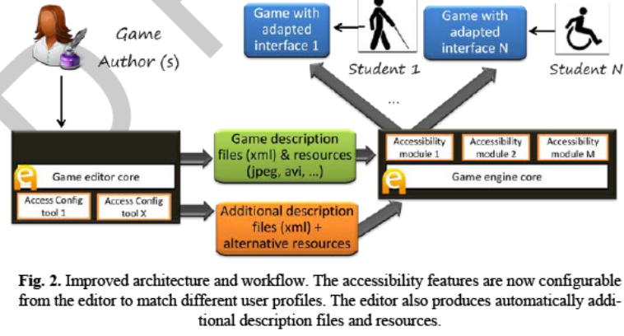
In addition to the blind and motor disability profiles, a new user profile was considered: users with low vision. Colleagues from Techno site identified the adaptations this profile needed, which included screen and text magnification and use of a high contrast color scheme. Low vision users were expected to have problems to inspect the game scenes and find interactive elements as for them shapes and images blur with the background of the scene or with other elements.
We tried to keep the human work needed to accommodate the needs of these users to a minimum. The approach followed was to develop a low vision mode in the game engine. We started by developing an alternative rendering mode that improved the contrast of the interactive elements over the background of the game scenarios. This kind of technique has been applied to improve the accessibility of other games in the past, although focus has been placed on a single title instead of trying to build a generic and reusable system. This kind of adaptation introduced the novelty of modifying the rendering pipeline (i.e. how the game is painted), in contrast to blind users and users with a motor disability that required adapting the modality. The game engine automatically applied a light green filter to the interactive elements which in-creased their brightness and a dark purple filter to decrease the brightness of other areas, facilitating the identification of those interactive elements. Font sizes and colors used for cursors, buttons and menus were also automatically adapted.
However further adaptations were needed. Through early prototypes we found out that some scenes could not be adapted by automatically applying a filter, like those using images with text embedded. In these cases, authors should produce alternative graphic resources and include them in the game manually.
Although "My first day at work" was focused on meeting the needs of the three be-spoken profiles (blind, motor disability and low vision), we also tried to make it accessible to users with cognitive disabilities. We wanted to explore the kind of adaptations these users require, who usually experience difficulties to understand complex language, memorize large pieces of information or present attention deficit disorders.
Dealing with these problems is much more complicated and there is little room for automation. The e-Adventure adaptation engine was used to provide alternative paths in the game with different levels of difficulty, or alternative versions of text intensive components such as conversations.
The game was evaluated by 10 users with a disability (3 blind users, 4 with low vision and 3 with reduced mobility). Apart from minor usability problems that could be solved by researchers during the experience, all users were able to complete the game (around 60 minutes of game play).

Level of automatic and semi-automatic adaptation
Table 1 shows a summary of the adaptations performed. Adaptations related to the modality, how the user interacts with the game or perceives the game feedback are prone to be automated (e.g. interfaces for blind users and users with reduced mobili-ty). This does not mean that solutions are straightforward, but that current state-of-the-art in technologies like text-to-speech or voice recognition allows building inter-faces that can be used by a high number of users. Once these interfaces have been built, they can be reused across different games with little extra work.

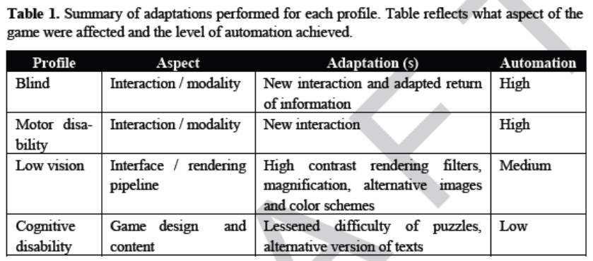

Other types of disability require adapting how the game is rendered (e.g. users with low vision). The process can be automated to some extent, as the rendering pipeline in game engines can be configured to apply transformations over specific elements, like applying filters, using alternative color schemes (for example to deal with color blindness) enlarging images or providing a magnifier. However, there is a point where alternative versions of art resources may be needed, having a greater impact on the cost of the game. In the case of the game "My First day at work", it was necessary to produce 647 art resources in first instance, including images, animations for characters, videos and sounds. To make it accessible for users with low vision it was needed to produce alternative versions of 53 art resources, an increase of 7,57%. Although this value is not very high it could increase exponentially if more profiles were considered (e.g. users with color blindness), so it is important to keep the number of manually crafted alternative resources as low as possible.
Non-Automated adaptations and auditing tools
Other accessibility profiles (e.g. those related to cognitive disabilities) may not be subject to automatic adaptation and therefore are harder to address. The adaptations they require are related to the design of the game, which is difficult to analyze and modify without requiring the intervention of the game author. Some AI techniques could be explored to solve some of the problems, like using automatic text analysis to simplify the language used if the user has a cognitive disability.
In these cases other approaches could be followed. Game authors could be provided with tools to perform accessibility auditing over the games, following the guide-lines of the W3C ATAG recommendation. These tools would work as accessibility evaluation tools for the web, searching the game structure for potential accessibility barriers (e.g. complex language, too many interactions available in a game scene, use of time pressure, etc.).
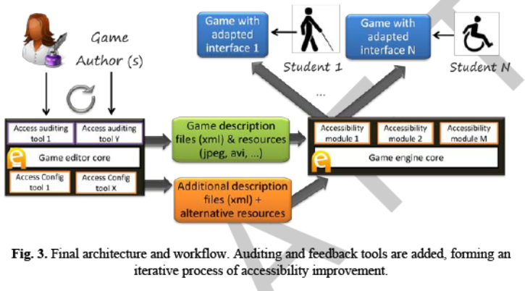

An additional benefit of inspection and auditing tools is that they are educational, as they can recommend solutions to the game author and give further details about why problems encountered may endanger access for users with disabilities. The results of the auditing process could be presented in a human readable report, but could also be displayed in their context while the game runs to maximize the educational value. However, developing auditing tools is only feasible if the structure of the game is explicitly defined, as it is in e-Adventure and most game authoring software, but not in game engines or frameworks where the game structure emerges or is implicitly defined. The final diagram of editing and running accessible games would look like the one figure3 shows.

Comparison criterion 3

Comparison criterion 4

Comparison criterion …

Comparison criterion n

Technique 2
Overview paragraph
What papers are discussed here? [ref][ref][ref]

Comparison criterion 1

Comparison criterion 2

Comparison criterion 3

Comparison criterion 4

Comparison criterion …

Comparison criterion n

…

Technique n
Overview paragraph
What papers are discussed here? [ref][ref][ref]

Comparison criterion 1

Comparison criterion 2

Comparison criterion 3

Comparison criterion 4

Comparison criterion …

Comparison criterion n

…

???? // collection n
xxx

Technique 1
Overview paragraph
What papers are discussed here? [ref][ref][ref]

Comparison criterion 1

Comparison criterion 2

Comparison criterion 3

Comparison criterion 4

Comparison criterion …

Comparison criterion n

Technique 2
Overview paragraph
What papers are discussed here? [ref][ref][ref]

Comparison criterion 1

Comparison criterion 2

Comparison criterion 3

Comparison criterion 4

Comparison criterion …

Comparison criterion n

…

Technique n
Overview paragraph
What papers are discussed here? [ref][ref][ref]

Comparison criterion 1

Comparison criterion 2

Comparison criterion 3

Comparison criterion 4

Comparison criterion …

Comparison criterion n

Conclusions
// conclusions from this section

// summary table
N rows (one row per comparison criteria), m columns (one column per technique)

Changes in learner's behavior are inevitable and many believe that game-based learning is one of the solutions to encourage learners to engage more in the learning process. In addition to the motivating factor of reintroducing play into learning, game-based learning offers an opportunity to embed a wide range of learning approaches. With the current generation of 'digital natives' being exposed to interactive entertainment during childhood years and being brought up in the digital era, we believe that game-based learning will become a preferred method of learning for many of this generation in the future. These beliefs are supported by JISC's "Guide to effective learning design" which states that learning should be congruent to lifestyle for effective learning to take place. Indeed there are a growing number of domain experts intending to take advantage of game-based learning and a growing demand for high-level tools which can help them create their own educational games. In this article, we have described how MDE can he used a platform for one such technological solution to the dilemma and outlined the benefits and challenges associated in creating a model-driven educational development environment.
Our survey provides insights on developments in this field which plays an important role collectively on the creation of a model driven game development environment. We identified these approaches and solutions, and reviewed them from MDE perspectives. Although most of the current approaches and solutions are related to model driven game development, using these approaches and solutions will require clever modification before
they can be deemed suitable to be integrated in a model driven game development framework. Nevertheless, it provides a reference for framework developers to begin with, extend or adapt. Although current efforts in model-driven game development mainly focus on mainstream audience (i.e. industry and hobbyist), there is a growing awareness of the adoption of MDE specifically for production of educational games and serious games. Developing a model-driven educational games development environment for use by domain experts requires a different treatment compared to present approaches. Pedagogic practices for educational games design should be embedded within the modeling environment to ensure any computer games produced are pedagogically sound. We are currently developing our own game definition model as well as a game software model for use in our own model-driven educational games development framework. Furthering our research efforts we intend to prototype a model-driven educational game development environment using our framework as a proof of concept. At a later stage of the research we aim to provide case studies on the use of the new tool and findings from the evaluation will be used to further improve this tool.

Your solution

Introduction
// introduction for this section

Overview figure, architecture with description (inputs, processing, outputs)
Describe in terms of the comparison criteria

Detailed description
xxx

subheading
xxx

subheading
xxx

Tool Support

subheading

Validation results
xxx

subheading
xxx

subheading
xxx

Conclusions
// conclusions for this section

Conclusions and Future Work

subheading
xxx

subheading
xxx

subheading
xxx

subheading
xxx

subheading
xxx

subheading
xxx

References
// use correct format for book, journal, conference paper
// avoid websites

- C. Shaun Longstreet, Kendra Cooper, A Meta-model for Developing Simulation Games in Higher Education and Professional Development Training, IEEE 17th International Conference on Computer Games, Kentucky, USA ,2012
- S. Tang, M. Hanneghan, A Model-Driven Framework to Support Development of Serious Games for Game-based Learning, School of Computing and Mathematical Sciences, Liverpool John Moores University, UNITED KINGDOM, 2010 Developments in E-systems Engineering, IEEE Computer Society, 2010 .
- Cheng-ping Chen, Ju-ling Shih, A Prototype on a Meta-model for Designing Instructional Pervasive Games, Department of Information and Learning Technology, National University of Tainan, 2012 Fourth IEEE International Conference On Digital Game And Intelligent Toy Enhanced Learning, 2012.
- Sara de Freitas, Learning in Immersive Worlds: A review of game-based learning, Prepared for the JISC e-Learning Programme.
- Jeannette Bennett, Kendra Cooper, Lirong Dai, Aspect-oriented model-driven skeleton code generation: A graph-based transformation approach, Science of Computer Programming 75, pp: 689_725, 2010.
- Antti Kirjavainen, Development of Game-Based Learning Environments – Constructing a Quality Multi-Disciplinary Development Process, University of Jyvaskyla, Department of Mathematical Information Technology & Agora Center, Dissertation in Information Technology, October 6, 2009.
- Masoud Hemmasi, Lee A. Graf, Illinois State University, EDUCATIONAL EFFECTIVENESS OF BUSINESS SIMULATION GAMING:A COMPARATIVE STUDY OF STUDENT AND PRACTITIONER PERSPECTIVES, Development In Business Simulation & Experiential Exercises, Volume 18, 1991.
- S. Tang, M. Hanneghan, Fusing Games Technology and Pedagogy for Games-Based Learning Through a Model Driven Approach, School of Computing and Mathematical Sciences, Liverpool John Moores University, Liverpool, UNITED KINGDOM, 2011 IEEE Colloquium on Humanities, Science and Engineering Research (CHUSER 2011), Dec 5-6, Penang, 2011.
- Nathan Balasubramanian,Brent G. Wilson, GAMES AND SIMULATIONS, Society for Information Technology and Teacher Education (SITE), 2005.
- Tsung-Li Wang, Ya Fen Tseng, Learning Effect for Students with Game-based Learning on Meta-Analysis, The 6th International Conference on Computer Science & Education (ICCSE 2011), pp. 1291-1295, August 3-5, 2011. SuperStar Virgo, Singapore, 2011.
- Javier Torrente, Pablo Moreno-Ger, Baltasar Fernández-Manjón (2008). Learning Models for the Integration of Adaptive Educational Games in Virtual Learning Environments. Proceedings of the 3rd International Conference on E-learning and Games (Edutainment 2008), Nanjing, China. Lecture Notes in Computer Science 5093, pp. 463–474.
- Miroslav Minović, Miloš Milovanović, Mladjan Jovanović, Dušan Starčević, Model Driven Development of User Interfaces for Educational Game, HSI 2009 Catania, Italy, May 21-23, 2009
- Lina Marcela Morales, David Mendez-Acuna, Willy Montes, Model Driven Game Development - Case Study A MTC for maze game prototyping Departamento de Ingeniera de Sistemas y Computacion, Universidad de los Andes, Colombia.
- Marcio de O. Barros, Alexandre R. Dantas, Gustavo O. Veronese, Claudia M. L.Werner, Model-driven Game Development: Experience and Model Enhancements in Software Project Management Education, Softw. Process Improve. Pract. pp. 411–421. 2006.
- Miroslav Minovic, Milos Milovanovic, Dusan Starcevic, Modeling Knowledge and Game Based Learning: Model Driven Approach, Journal of Universal Computer Science, vol. 17, no. 9 pp. 1241-1260. 2011.
- Diana Oblinger, Simulations, Games, and Learning, EDUCAUSE, May 2006.
- STEPHEN TANG, Martin Hanneghan, State of the Art Model Driven Game Development: A Survey of Technological Solutions for Game-Based Learning, Journal of Interactive Learning Research (201 1) 22(4), pp: 551 -606.
- Josephine M. Randel, Barbara A. Morris, C. Douglas Wetzel and Betty V.Whitehill, The Effectiveness of Games for Educational Purposes: A Review of Recent Research, Simulation & Gaming, 1991.
- Kendra Cooper, C. Shaun Longstreet, Towards Model-driven Game Engineering for Serious Educational Games: Tailored Use Cases for Game Requirements, IEEE 17th International Conference on Computer Games, Kentucky, USA ,2012.

Appendix A. title here

